**Hashing in DSA**

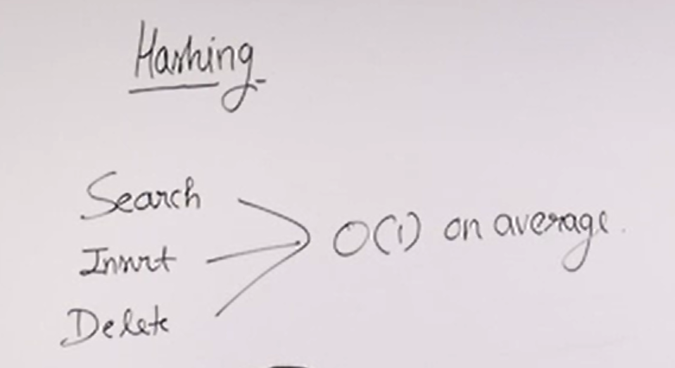

**For Arrays:**

Search 🡪 O(log n)

Insert 🡪 O(n) -------------- to move all elements

Delete 🡪 O(n)

**But Hashing is Not Useful for:**

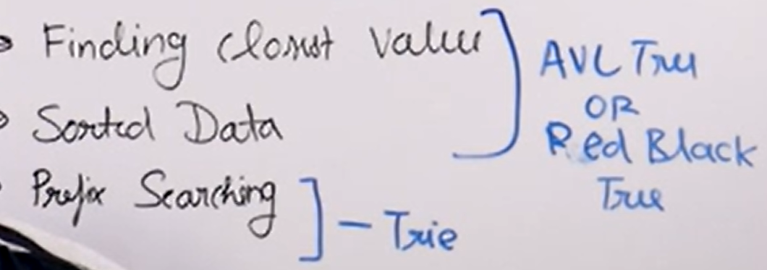

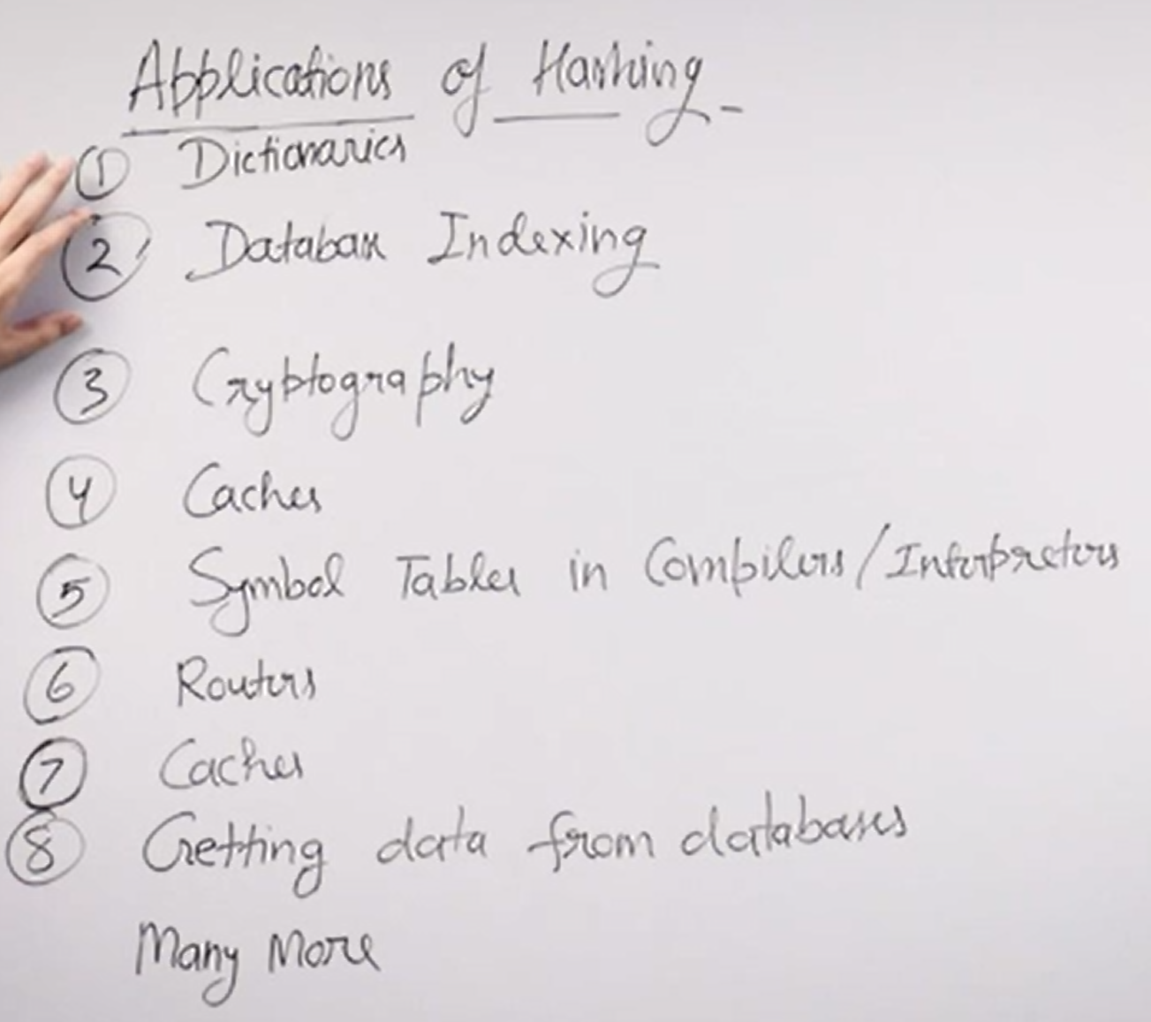

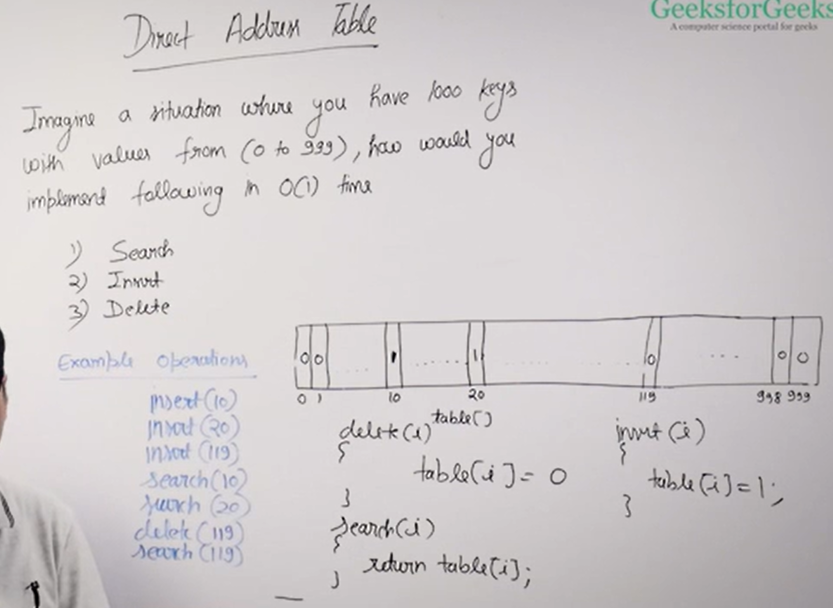

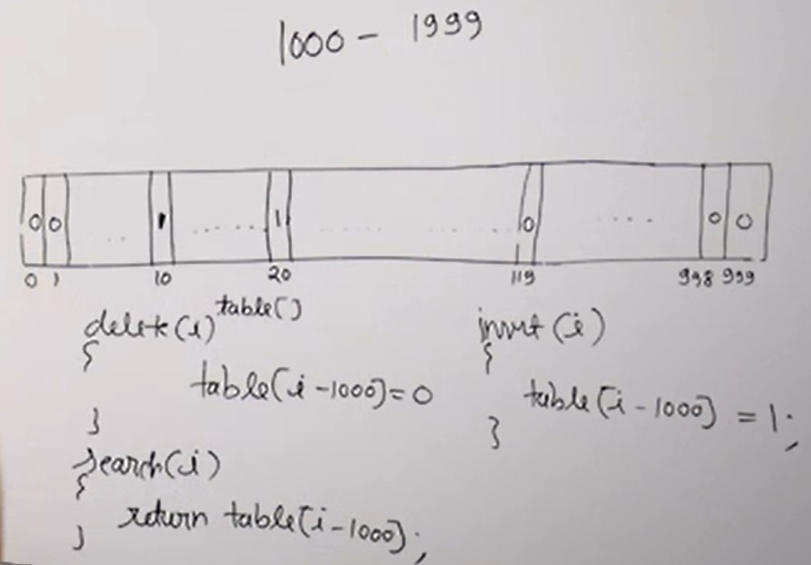

**But Problems with Direct Index(or address) Table:**

1. Does not handle large values (ex: 10 digit phone nums as keys)
2. Doesn’t handle floating point nums(i.e., floating num can’t be used as an index)
3. Does not handle strings (i.e., string can’t be used as an index)

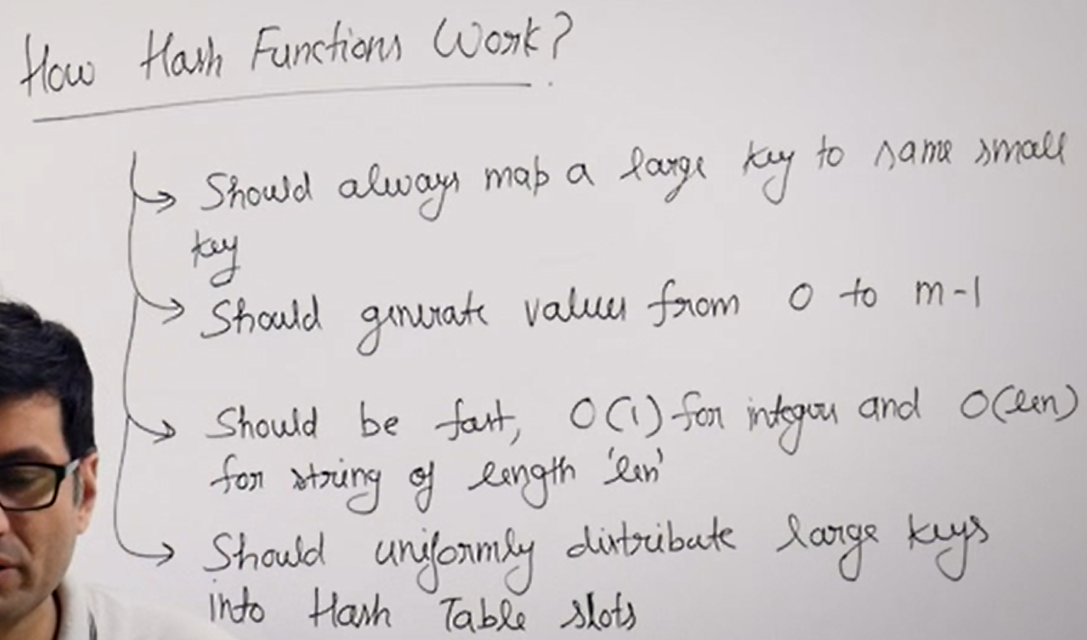

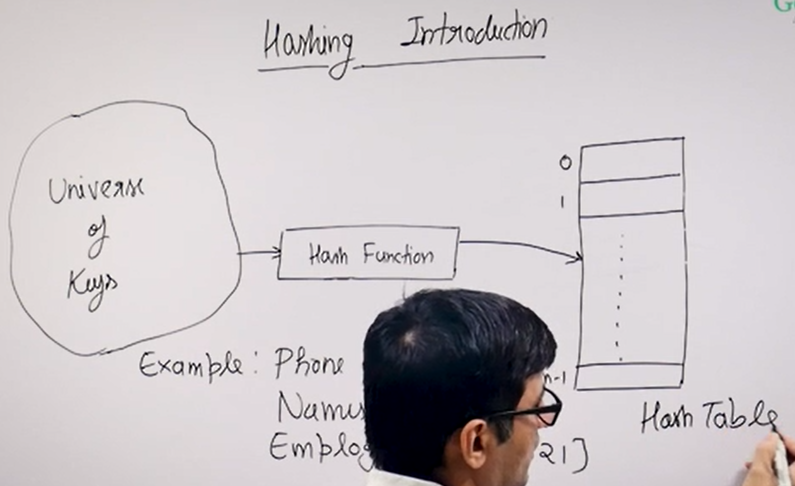

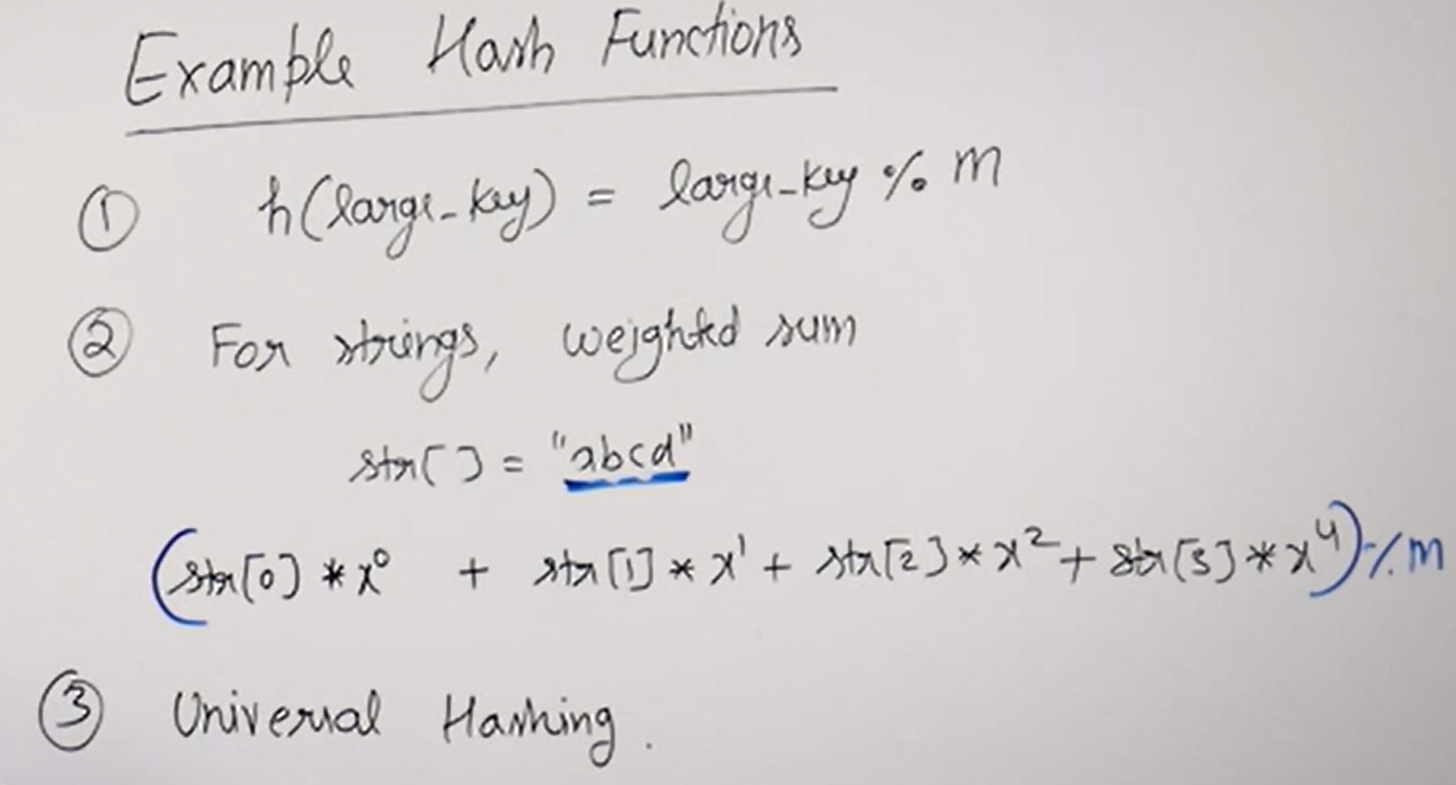

In second hash function x can be any number ( weighted sum ).

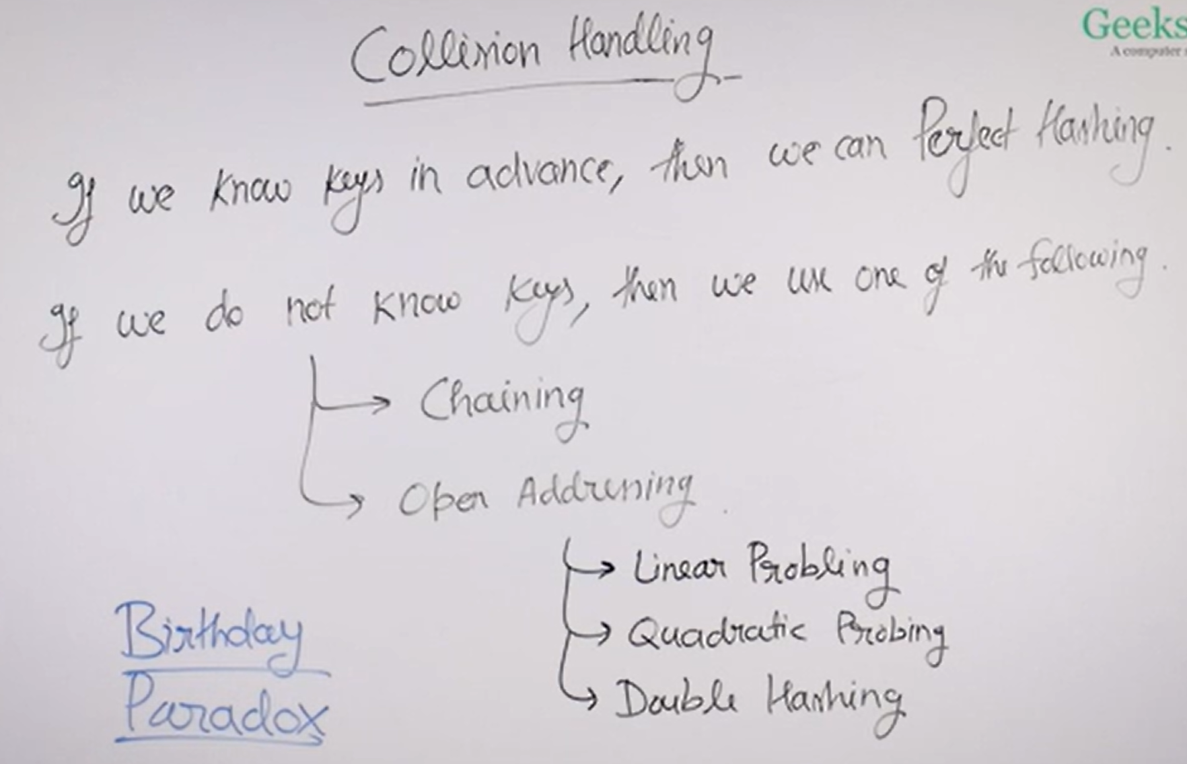

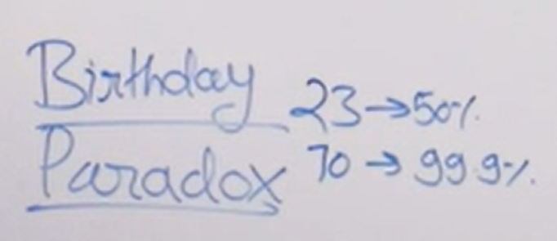

**1. Hashing with Chaining:**

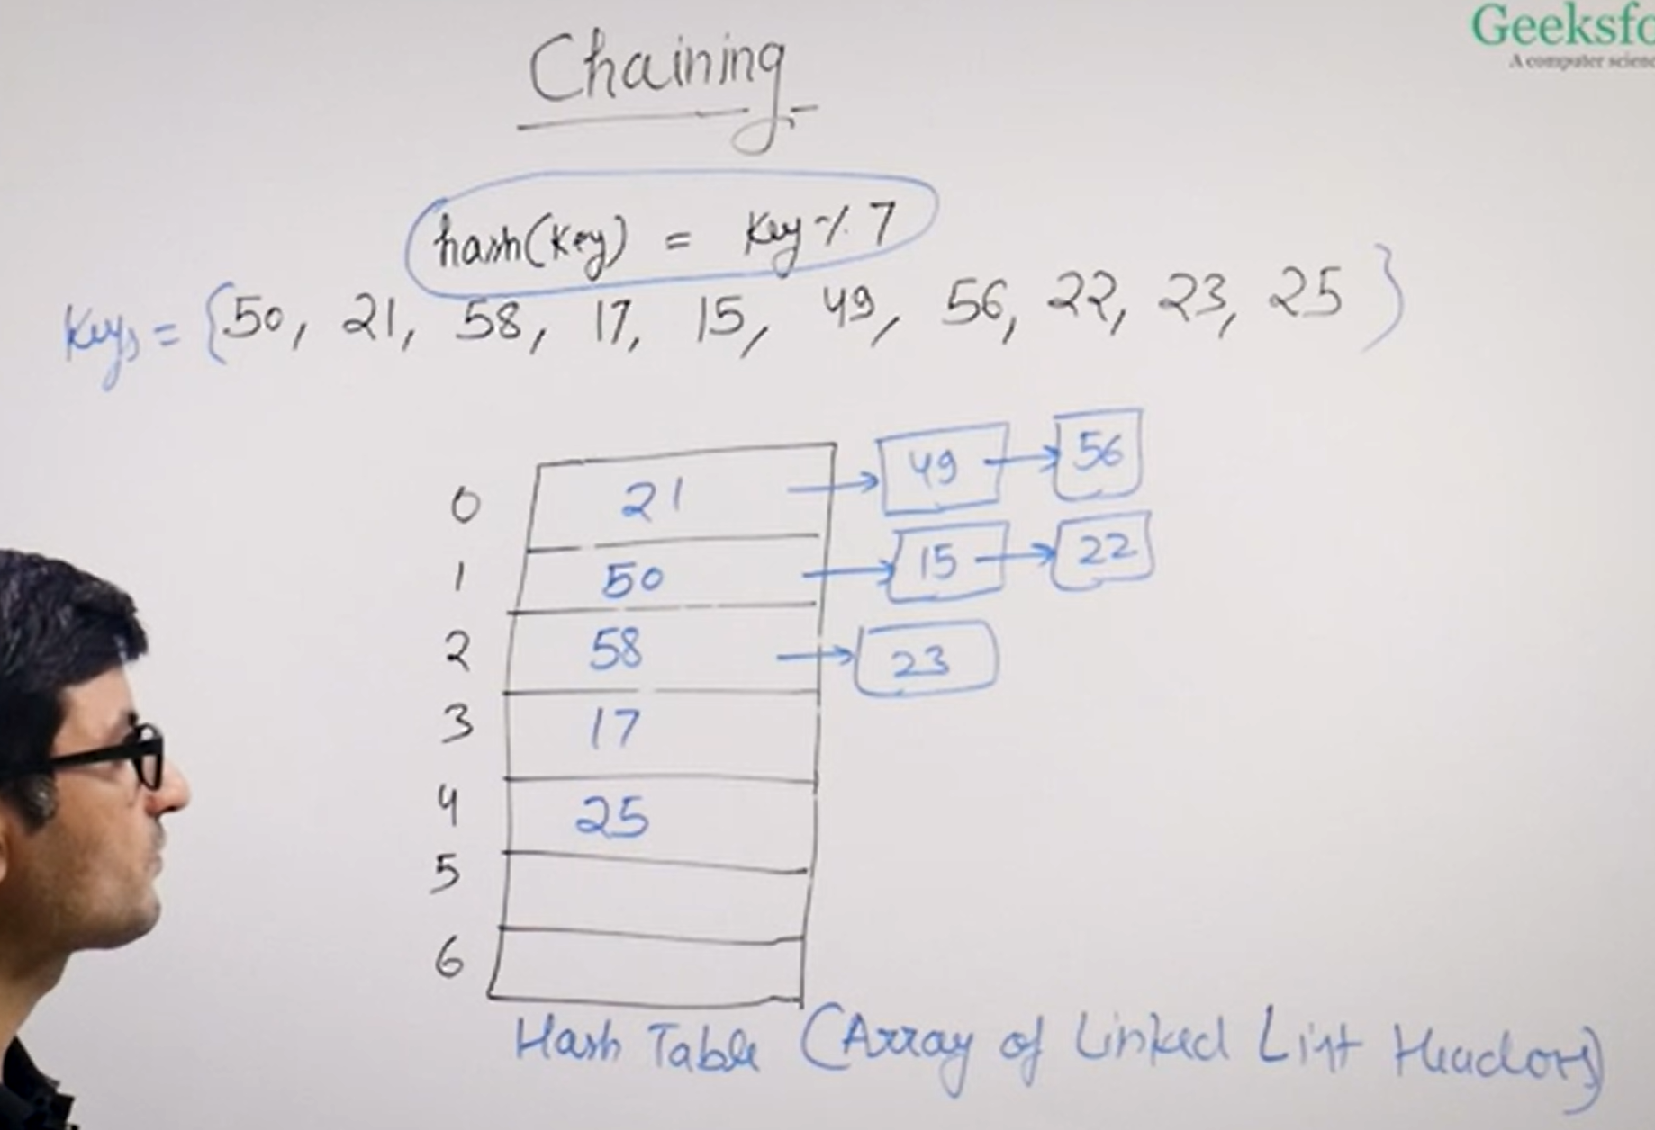

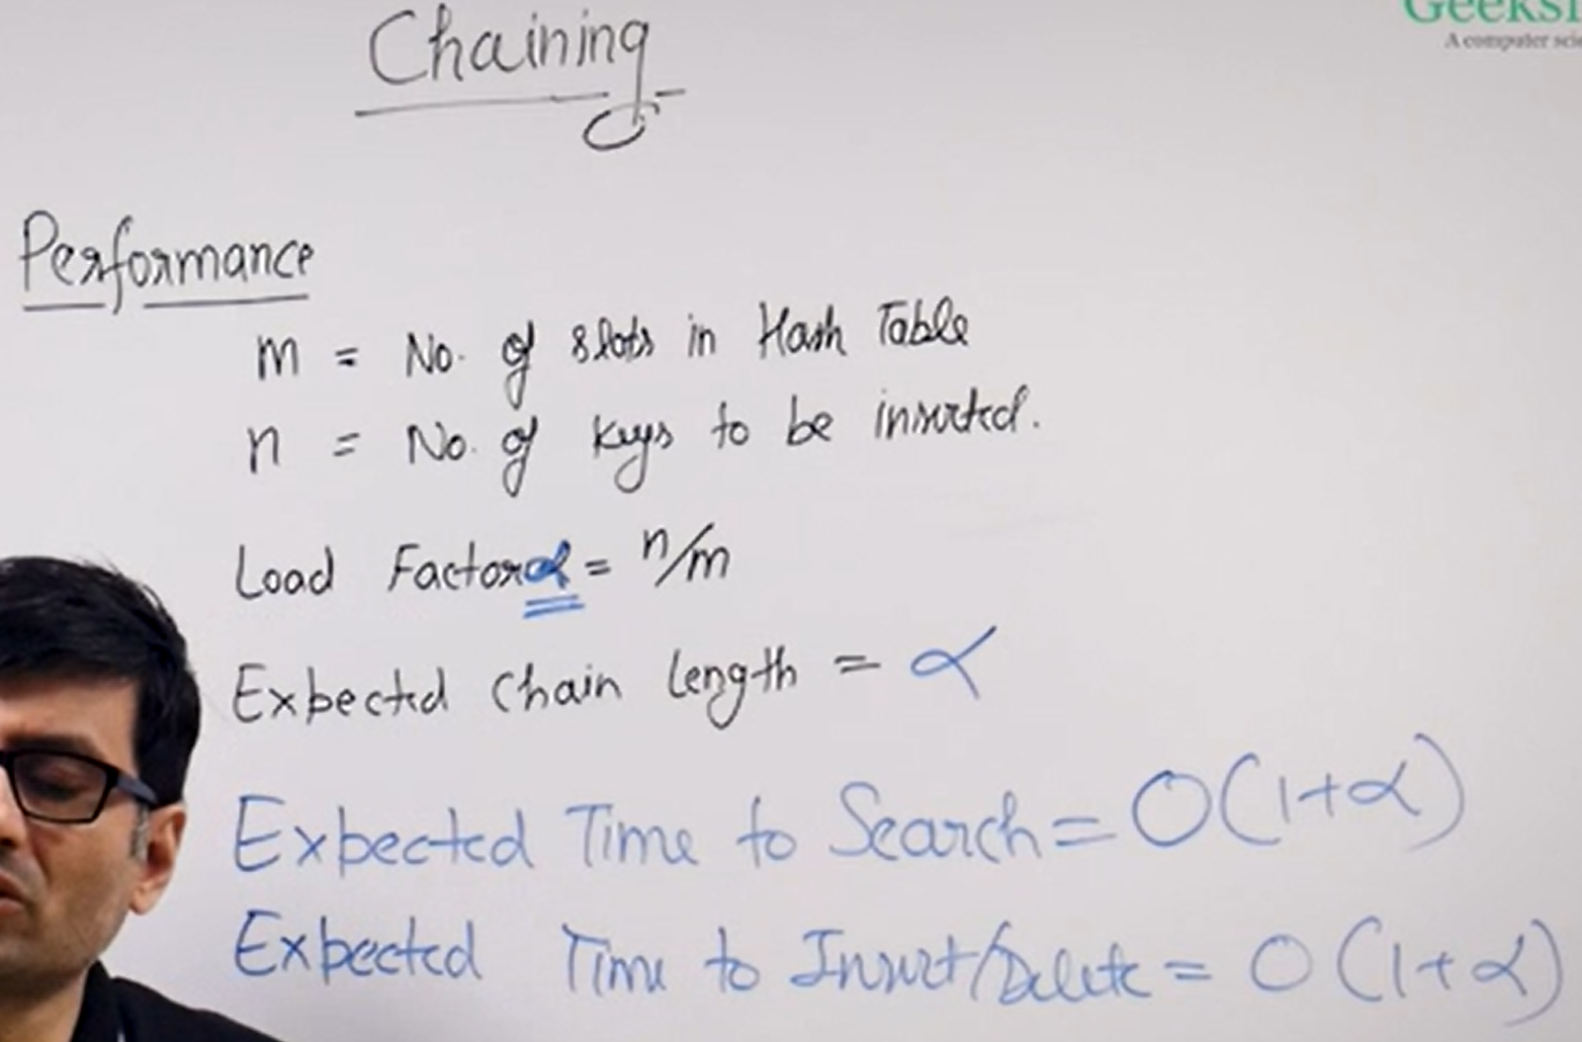

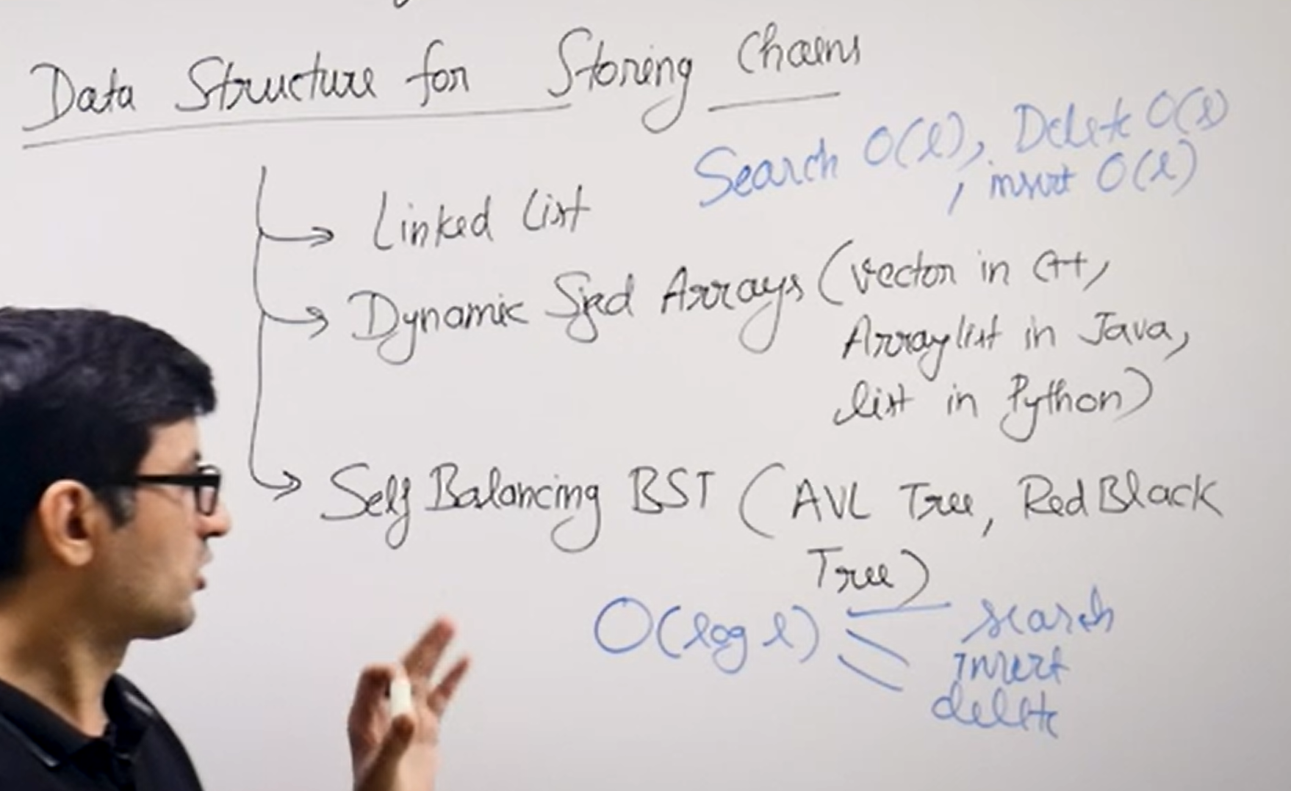

**Implementation of Chaining in JS:**

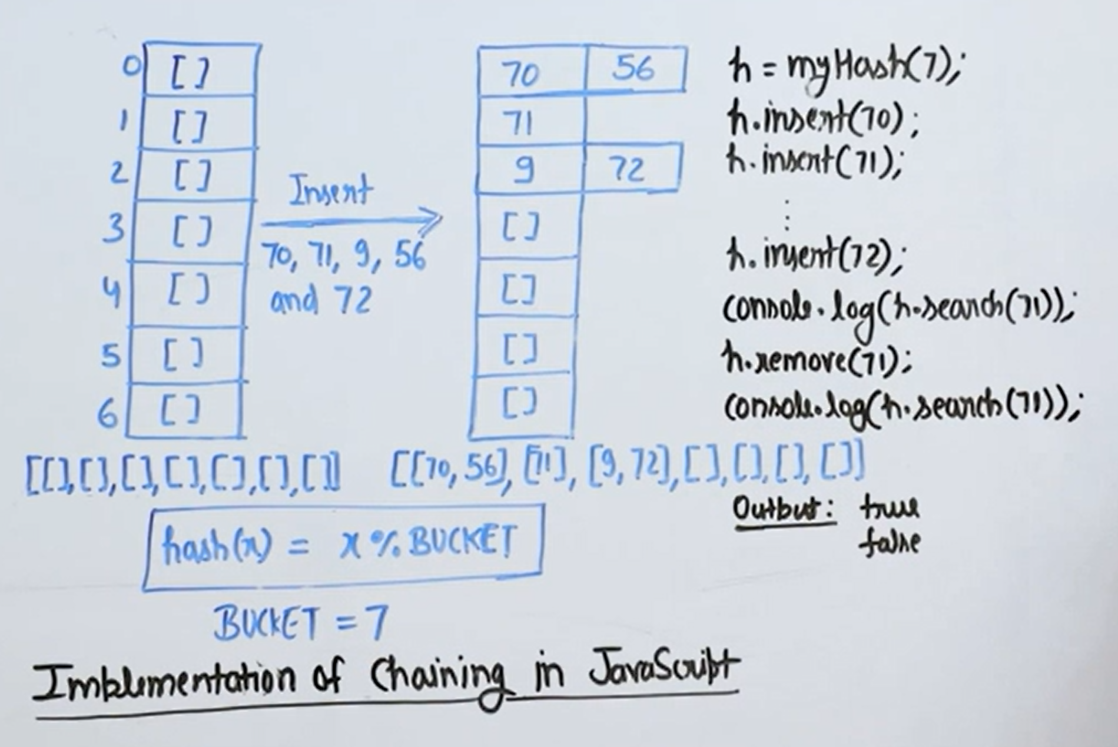

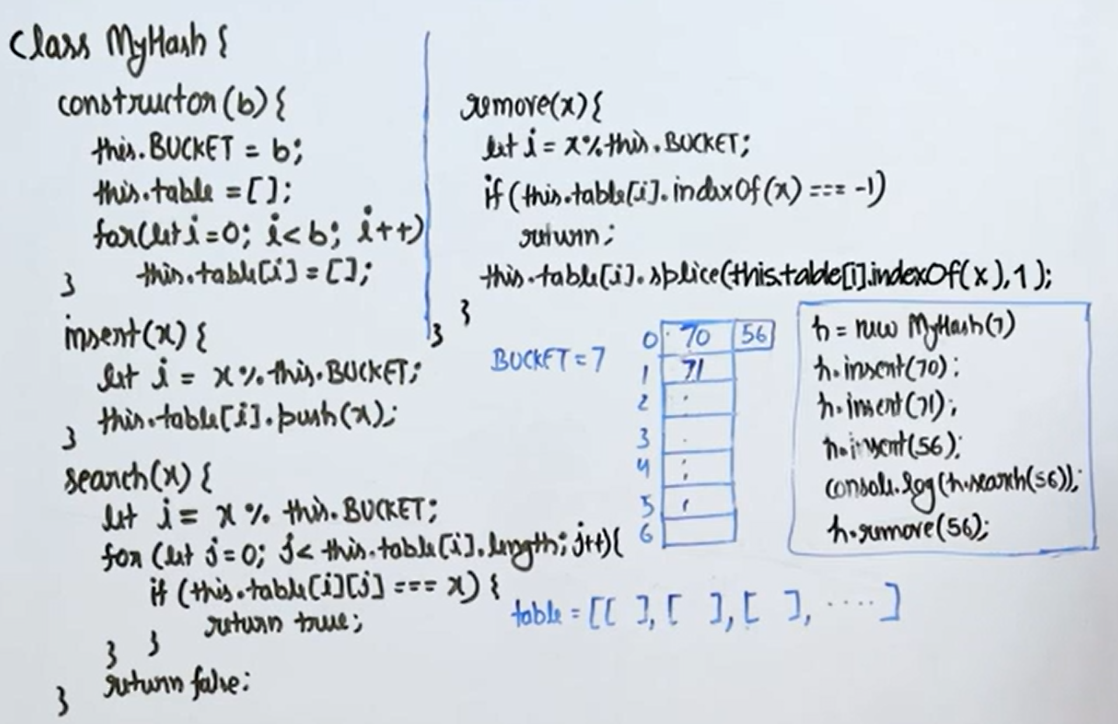

**2. Hashing with Open Addressing:**

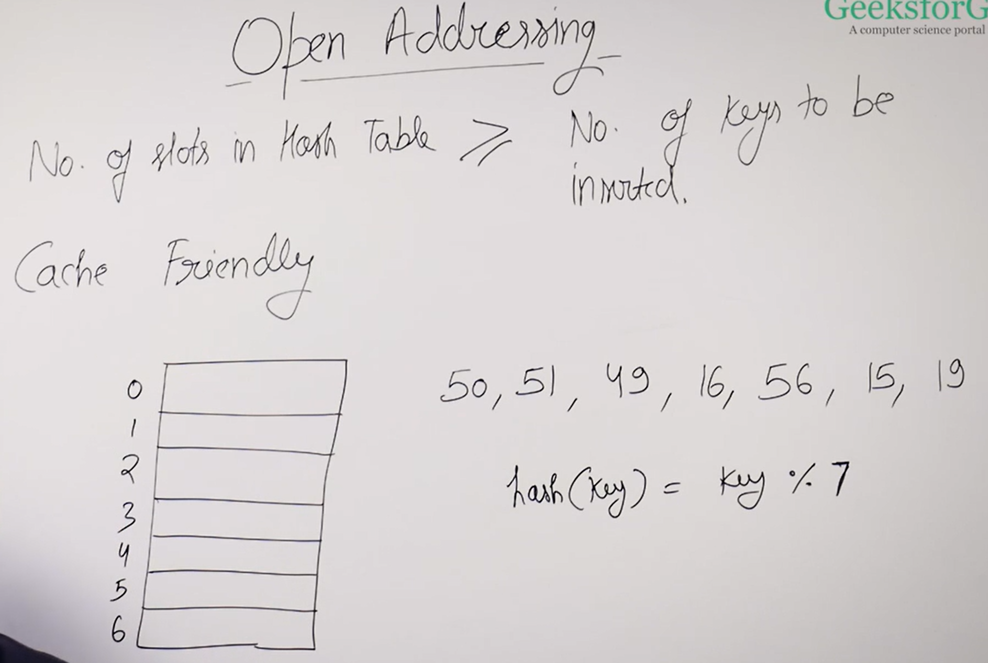

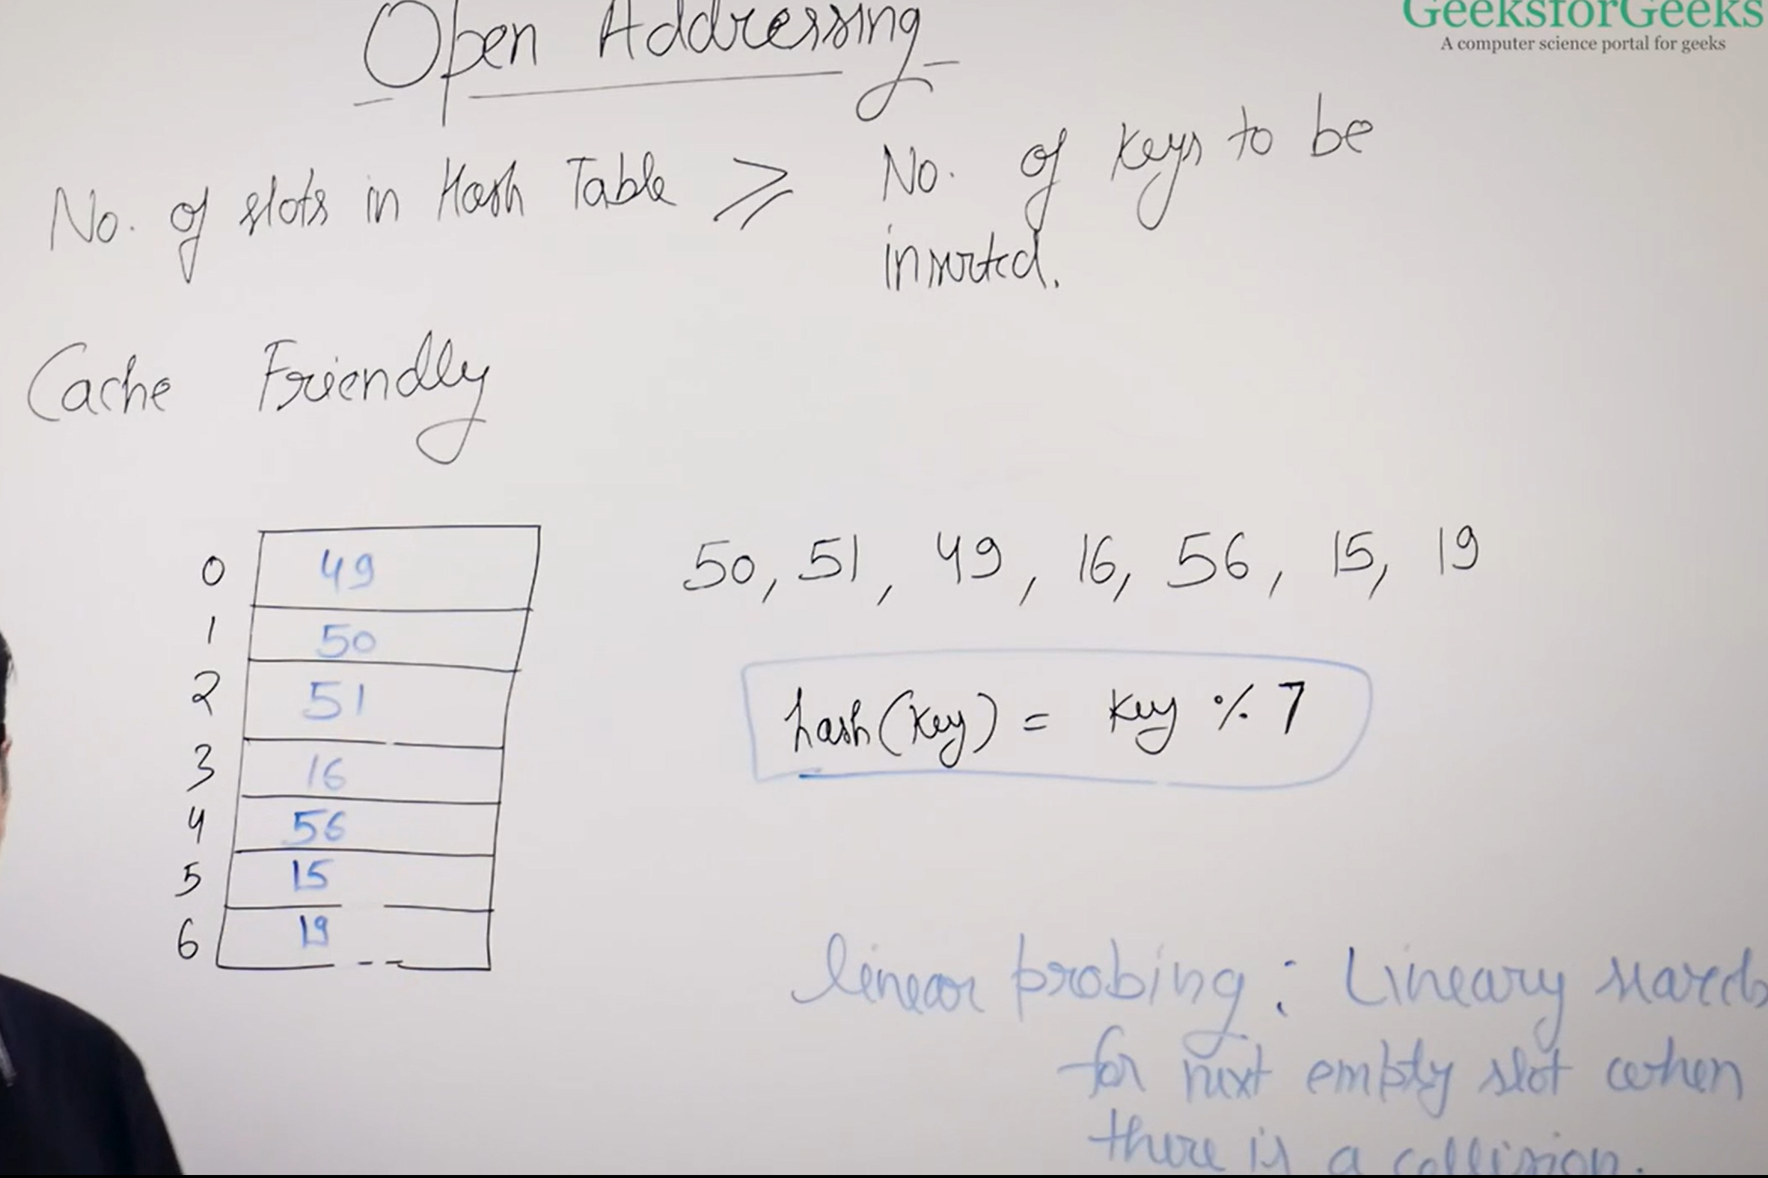

**Note**: While linear probing If last slot is reached & it is filled as well, then we will search for empty slot in circular way ( i.e., again searching from 1st slot )

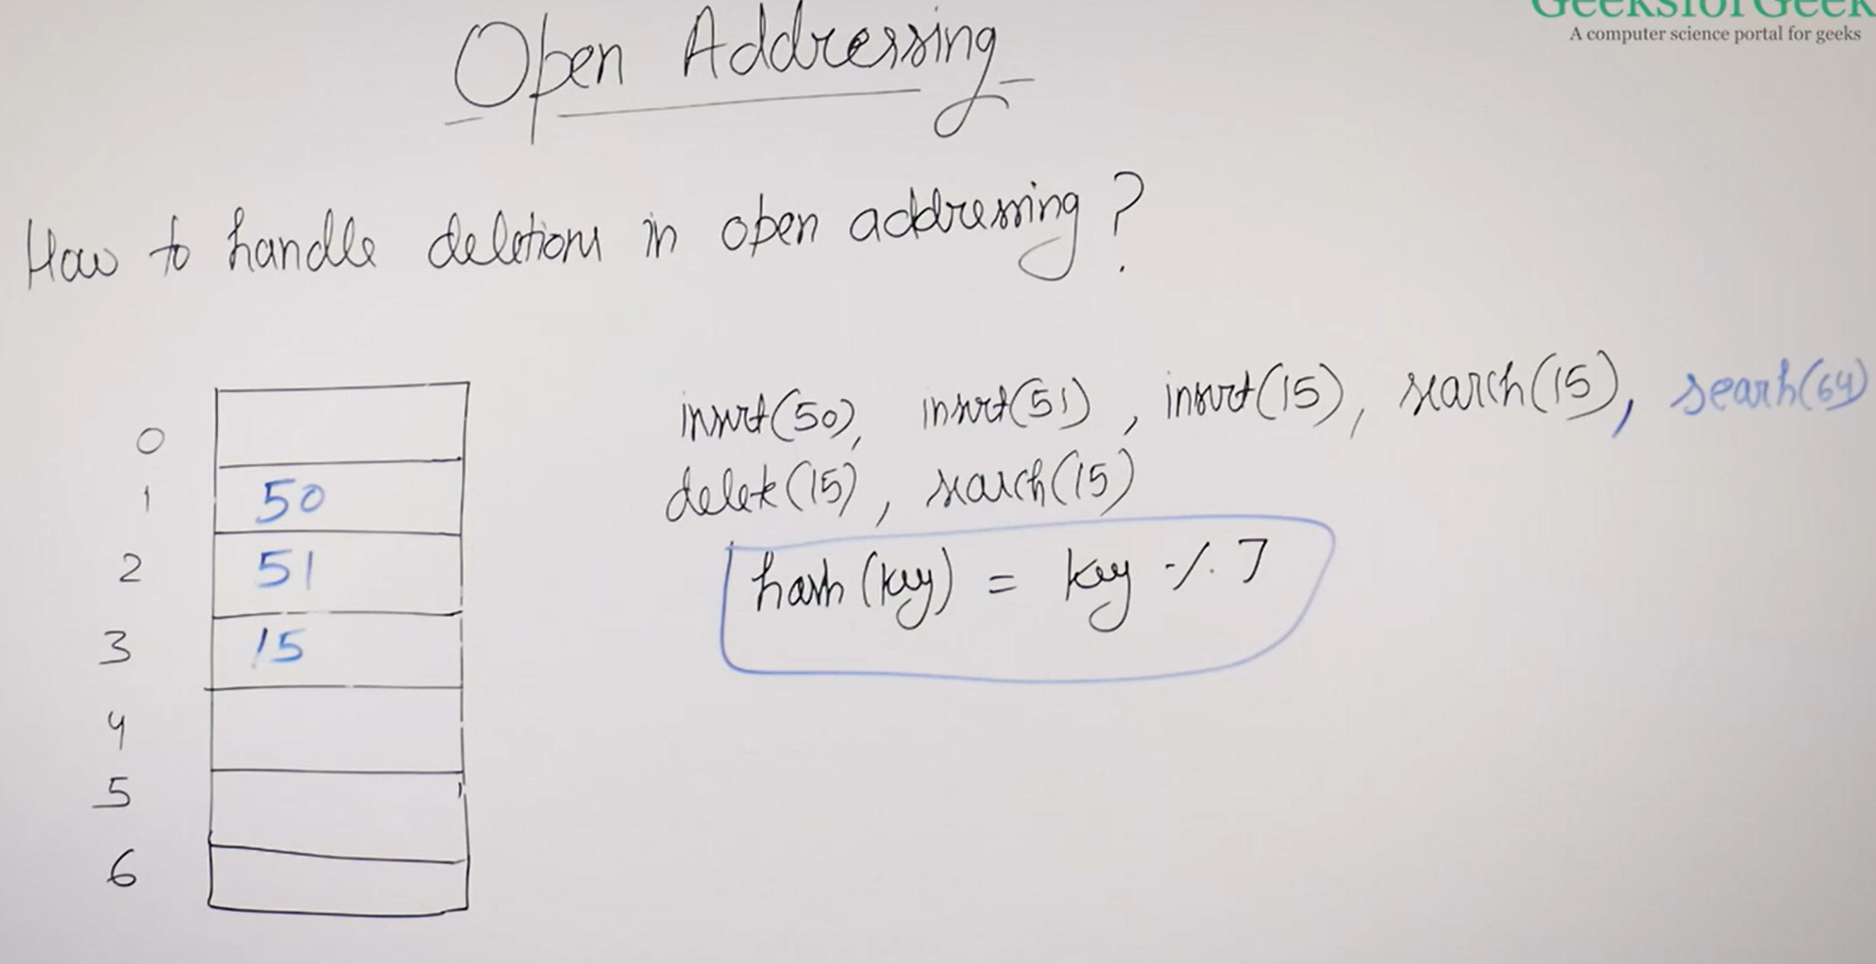

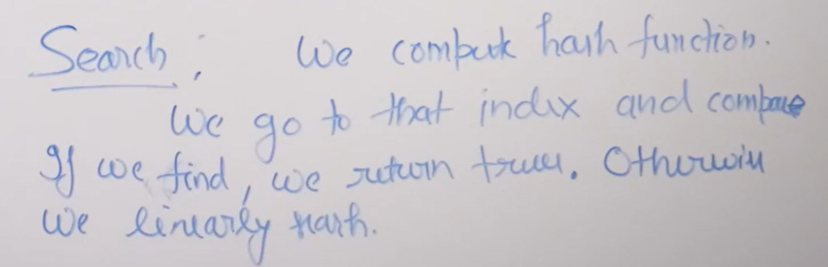

We Stop when 1of the 3 cases arise:

1. Empty Slot ( return false )
2. Key found ( return true )
3. Traverse through whole table ( return false )

**Problem with simply making slot empty when we Delete:**

It affects the search ( it will stop to search when it found empty slot. But there might be non-empty slots after that.)

So simply mark it as deleted instead of making empty.

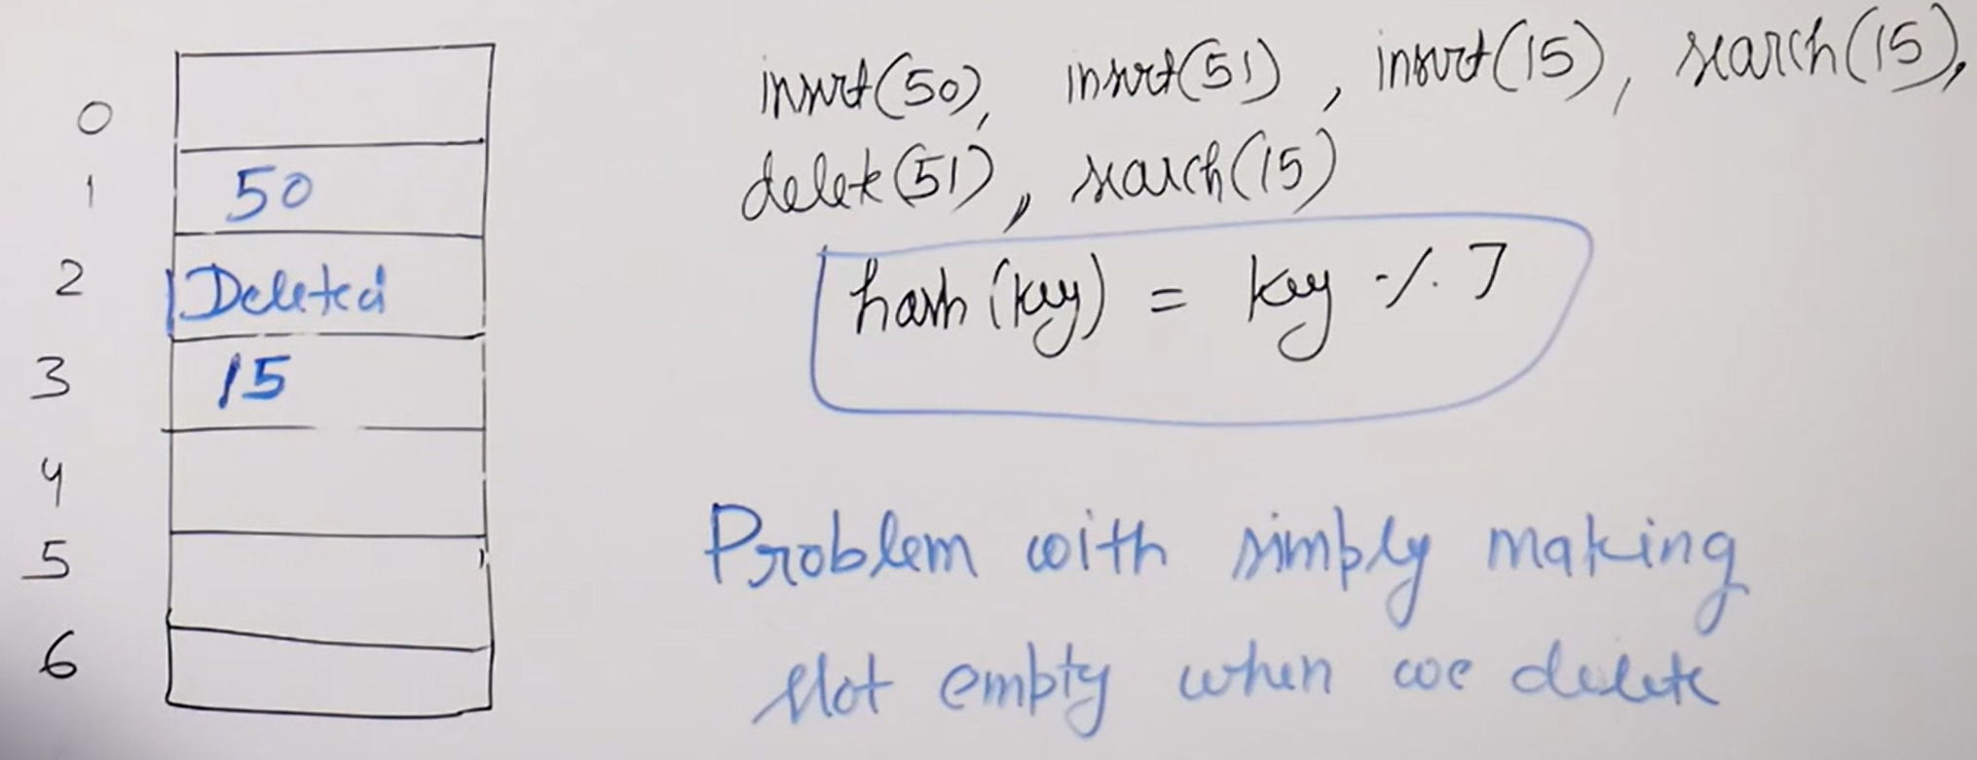

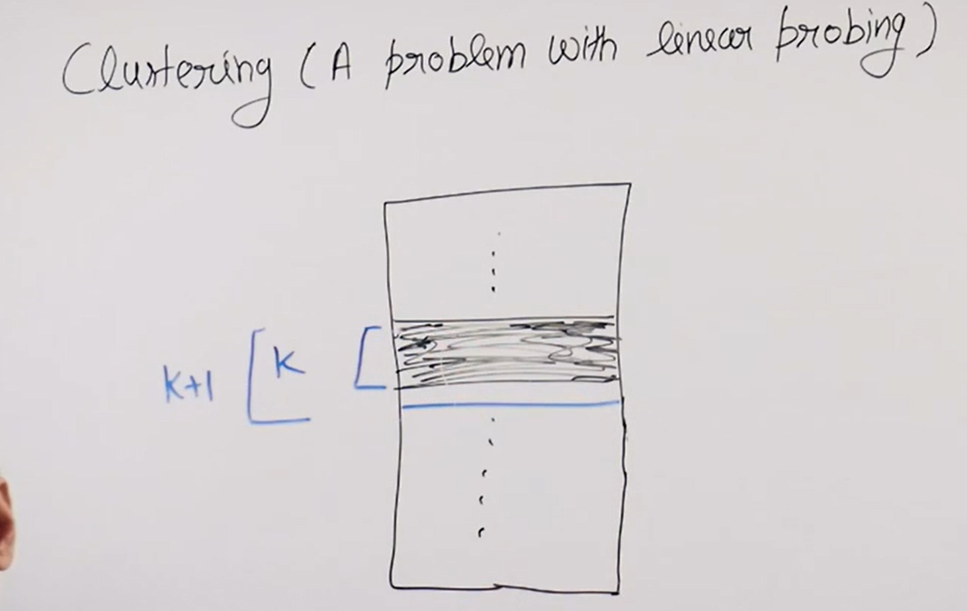

Linear Probing:

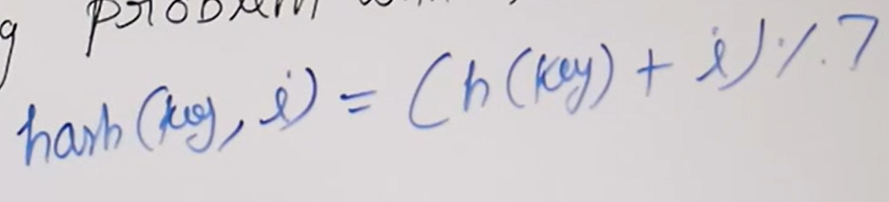

where,

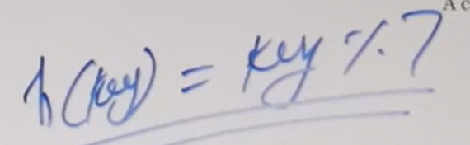

But in linear probing we have problem of primary clusters.

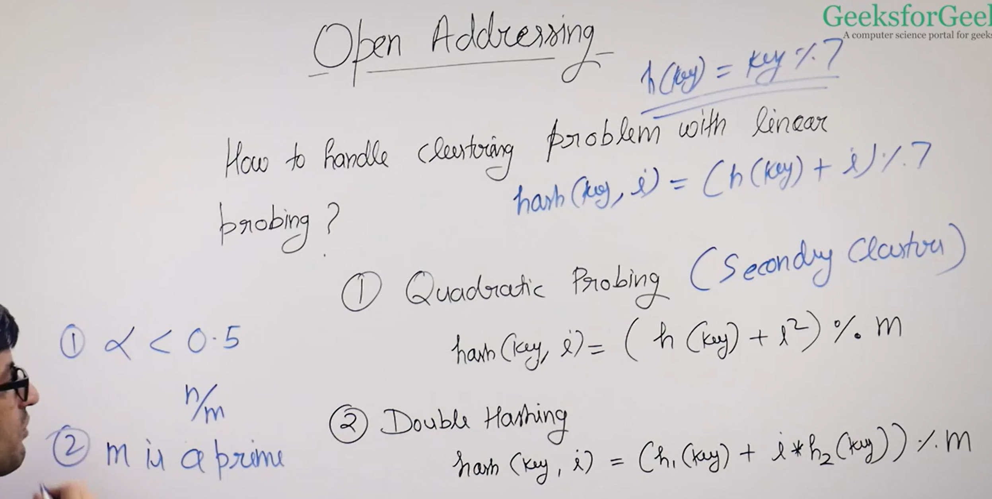

1. In Quadratic Probing we have problem of secondary clusters. But better than linear probing.
2. The disadvantage of Quadratic Probing compared to Linear probing is that, it may not find empty slots even they exist
3. Quadratic Probing guaranteed to work when Load Factor < 0.5 & m( i.e., hash table size ) is prime.

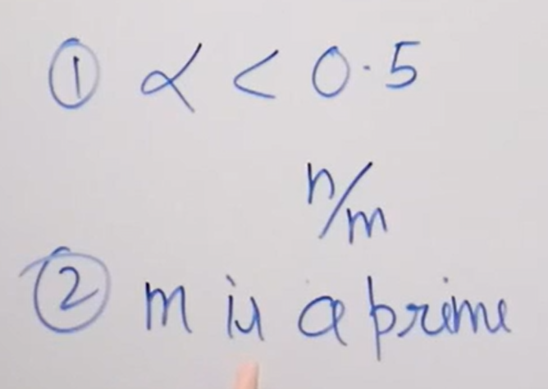

**Implementation of Open Addressing:**

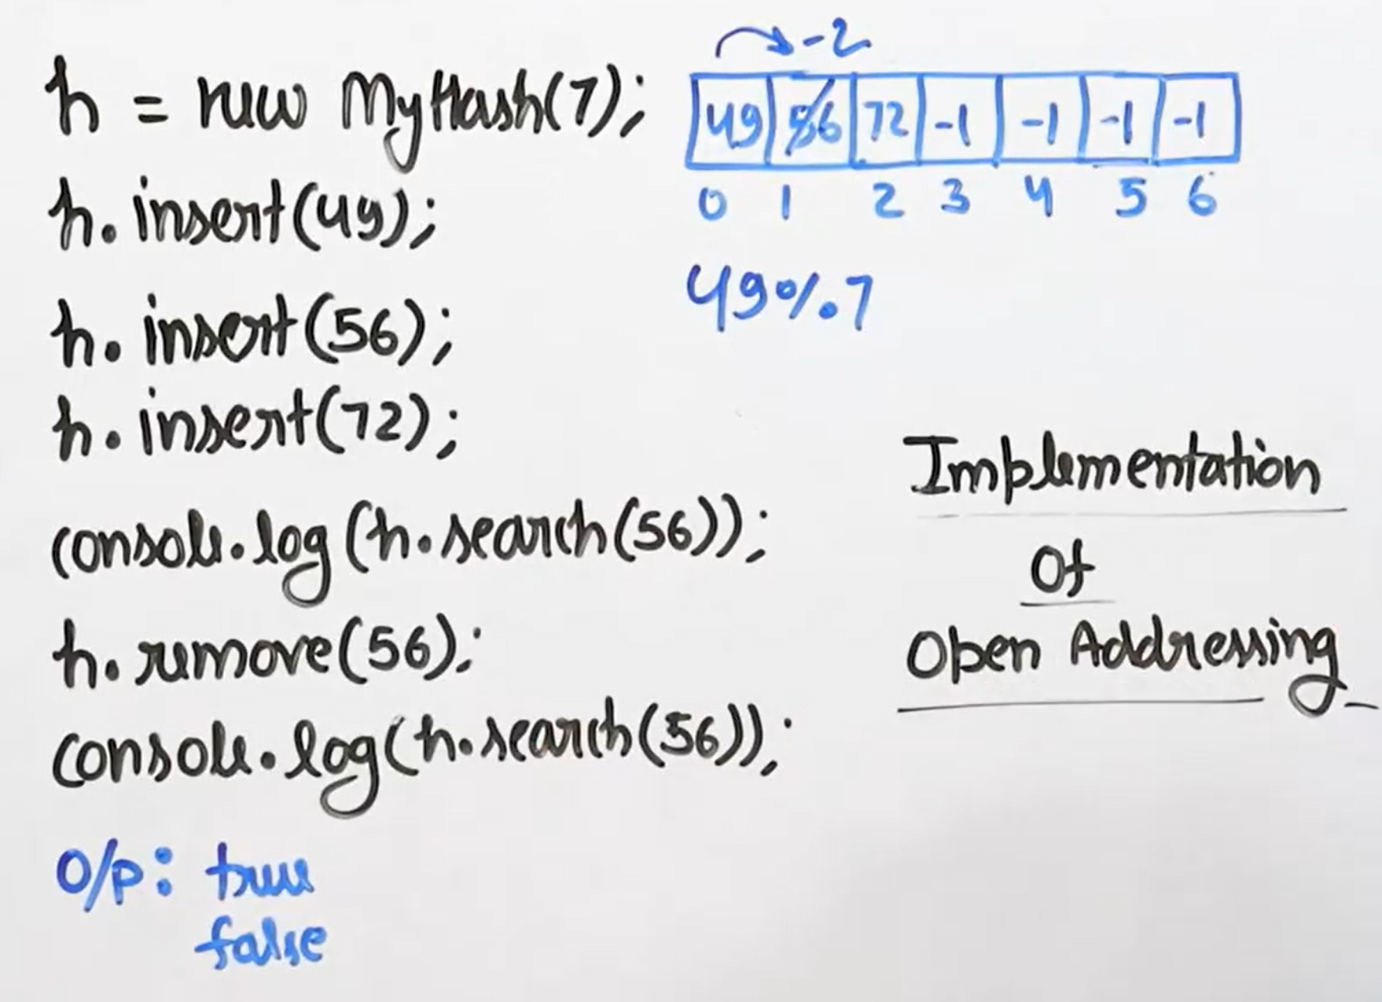

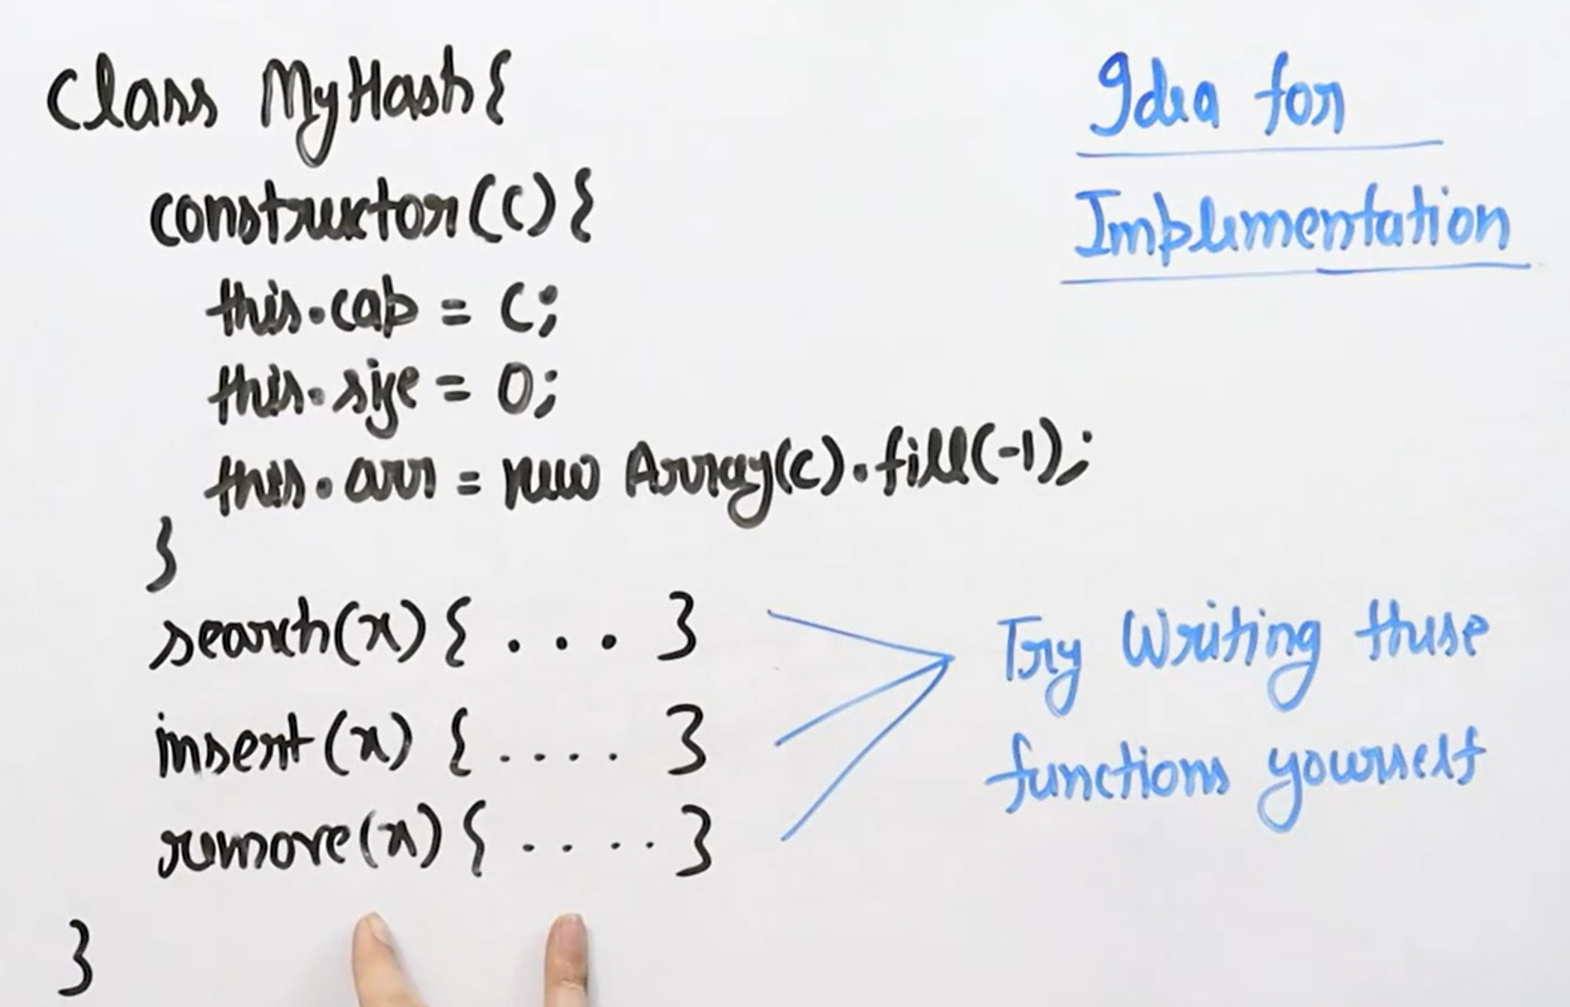

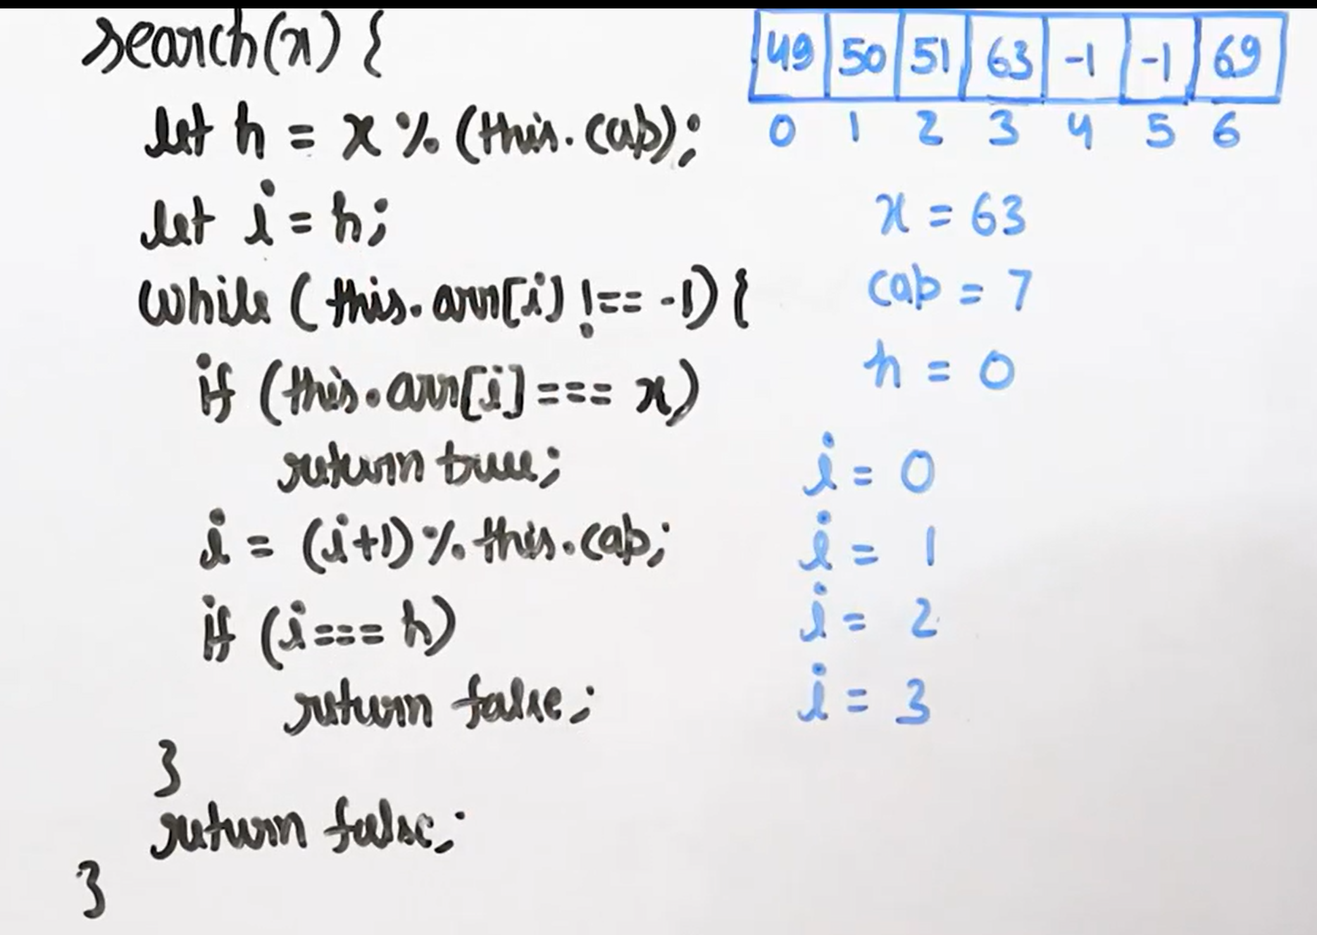

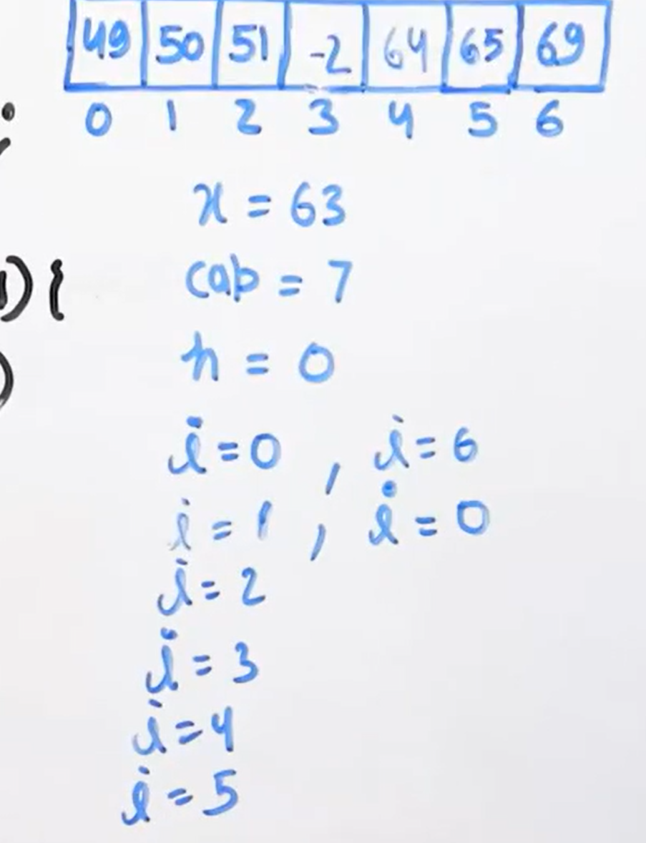

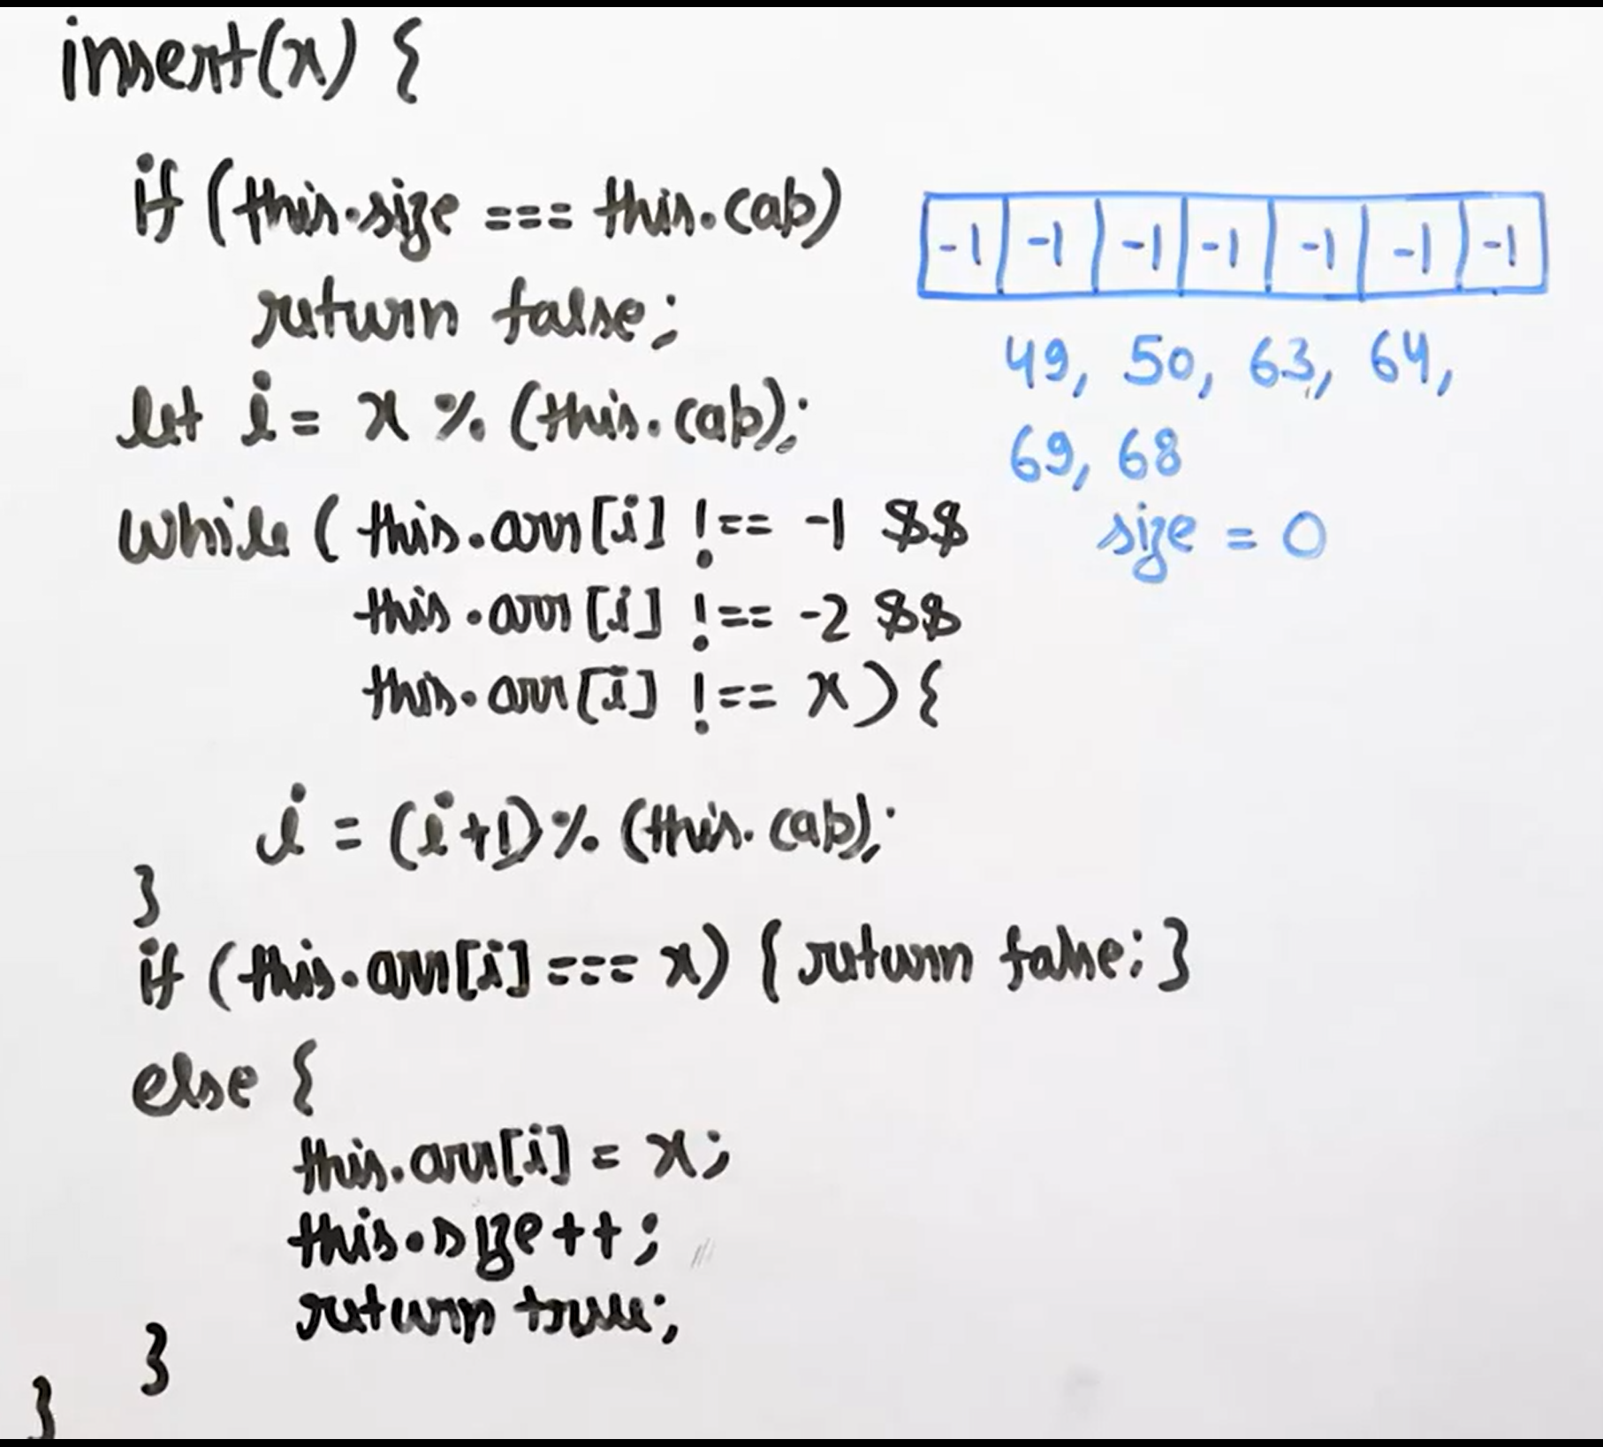

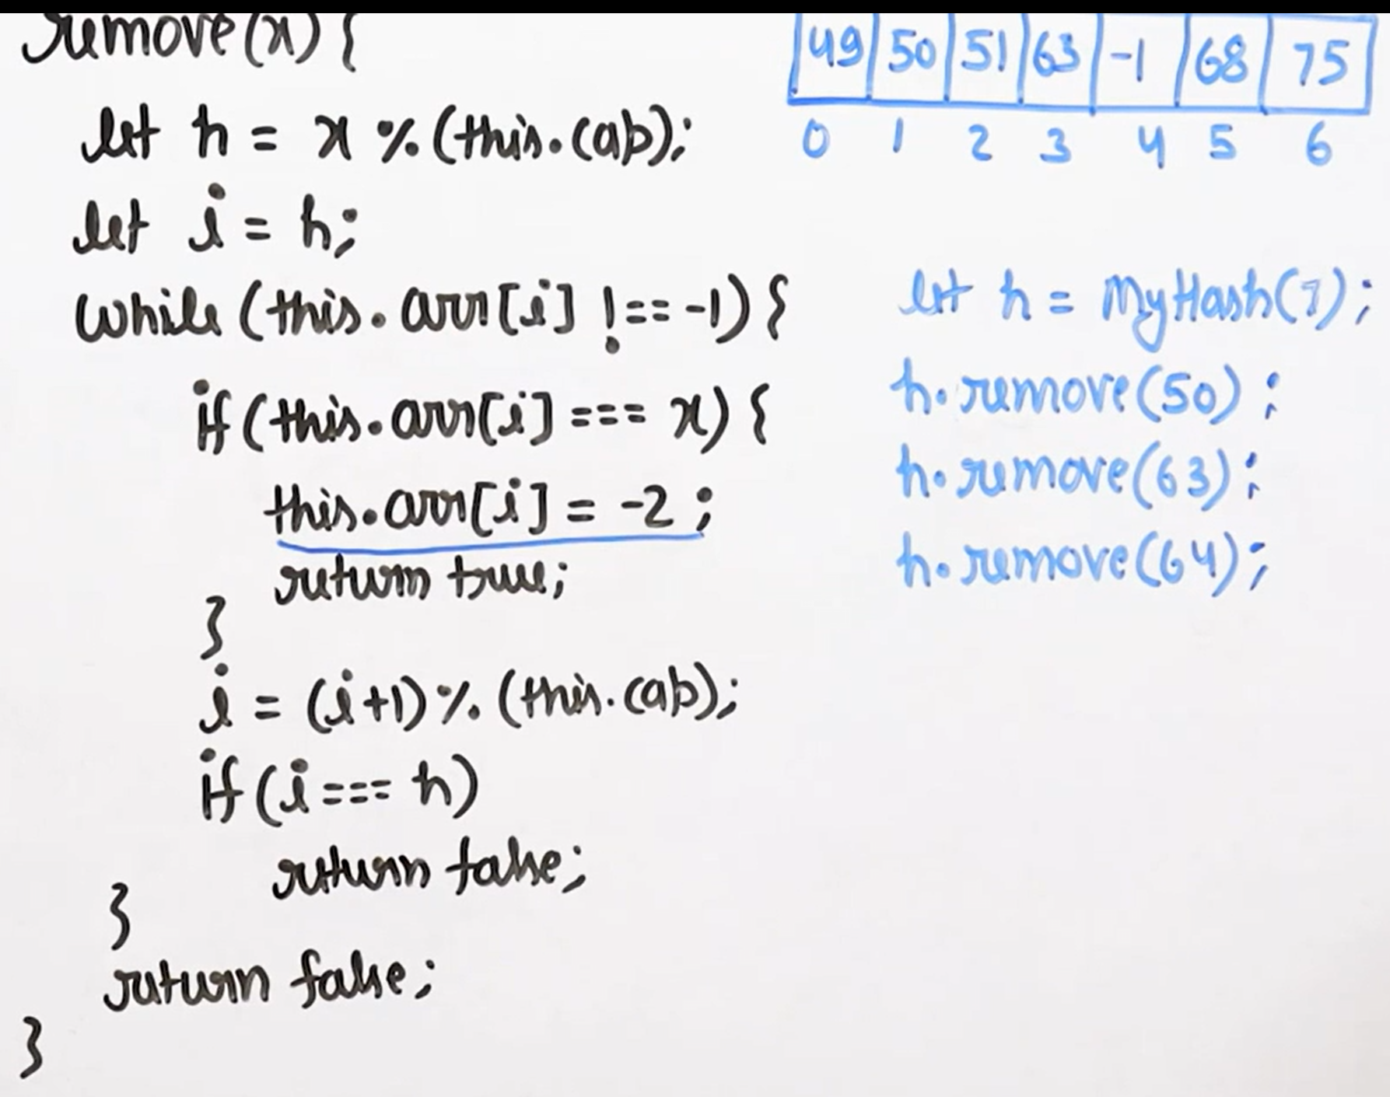

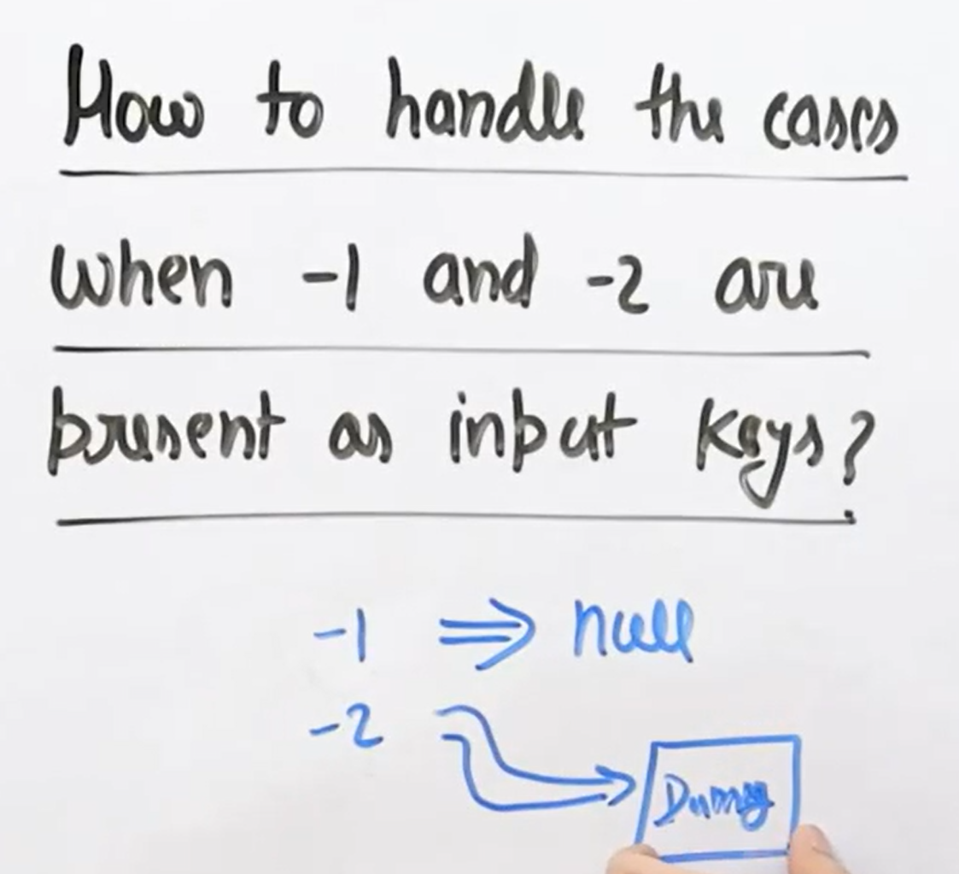

**Double Hashing Way in Open Addressing:**

